# 1 EDER Smoke Test Steps

1. Open ArcMap
2. Open the ED Master stored display from the ArcFM toolbar  
   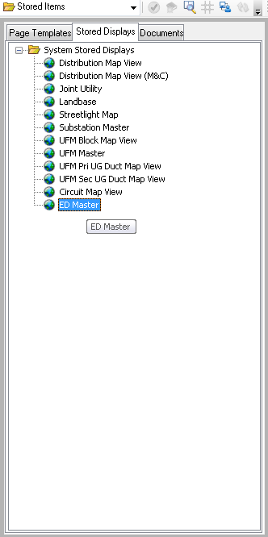
3. Click the Session Manager button in the ArcFM Session Manager toolbar to open the Session Manager.  
   
4. Select the green arrow next to Create Session  
   
5. Select the green arrow next to Open Edit Session  
   
6. Using the Zoom In tool from the Tools toolbar, zoom into the map around the Bakersfield area until the zoom level is less than 1:1000 in the Standard toolbar  
     
   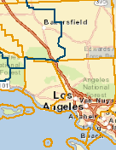  
   
7. If you do not have it already, open the PGE Job Number toolbar from Customize->Toolbars:  
   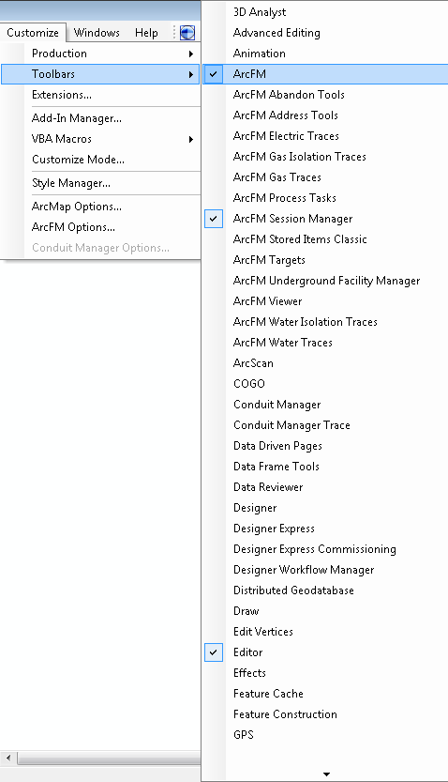
8. Enter in a number (any number) and press Enter.
9. Open up the ArcFM Attribute Editor from the ArcFM toolbar  
   
10. Select the Transformer from the Features tab of the Table of Contents  
    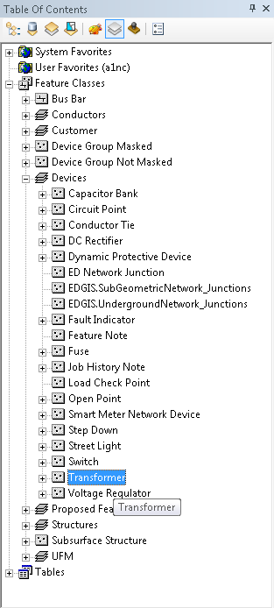
11. Fill out the attributes of the Transformer in the Targets tab of the Attribute Editor  
    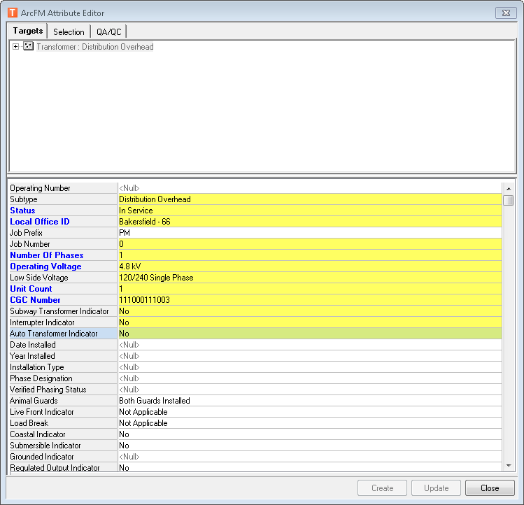
12. Place the feature on the map by selecting the Transformer entry in the Attribute Editor and clicking on the map. Place it so that it snaps to an overhead conductor.
13. Press OK to any warnings such as the following:  
    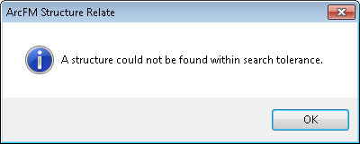
14. If the transformer places successfully, you will see a triangular-shaped symbol on the map and no errors will come up.
15. Select the two conductors that surround the transformer you just placed.
16. Ensure that each of the conductors has an Info record (e.g. Primary Overhead Conductor Info table).

# 2 Schematics Smoke Test Steps

1. After completing the above steps, wait until Schematics Change Detection picks up the changes
2. Open an ArcMap/ArcFM 10.1 instance and zoom to the location at which the Transformer was placed
3. You should see that Transformer in Schematics

# 3 WEBR Smoke Test Steps

1. Open WEBR and do an operating number search for ‘10503’
2. You should see three results and one of them should be for a Switch in Kern. Zoom to that Switch.
3. You should be able to zoom and see the Switch, which looks like this:  
   